**Exercise 1.1**

Q1. In computer jargon, what’s the different between a statement and a comment?

**Answer:** Statement is a line of code of instructions that will perform a task. While Comment is a statement that explain the functions of a code.

Q2. What does it mean to say that a program is portable?

**Answer**: Meaning they can run in different kinds of computers with few or no modifications.

Q3. In common English, what does the word compile mean?

**Answer**: Compiler reads the entire program and translates it completely before the program starts running.

Q4. What is an executable? Why is that word used as a noun?

**Answer**: Executable is translated program into object code. it perform process of action or instruction without further translation. The reason why it used as a noun, it run faster than interpreted programs.

**Exercise 1.2**

Q1. Type in the hello world program, then compile and run it.

**Answer**:

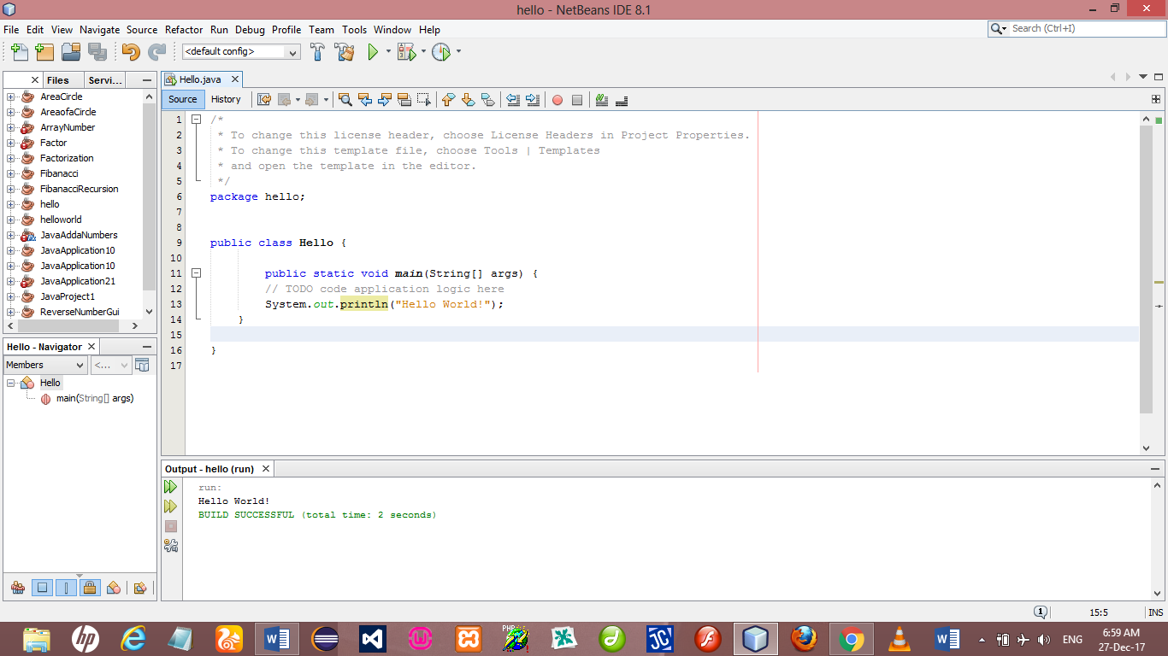

Q2. Add a print statement that displays a second message after the “Hello,

World!" Say something witty like, “How are you?" Compile and run the program again.

**Answer**:

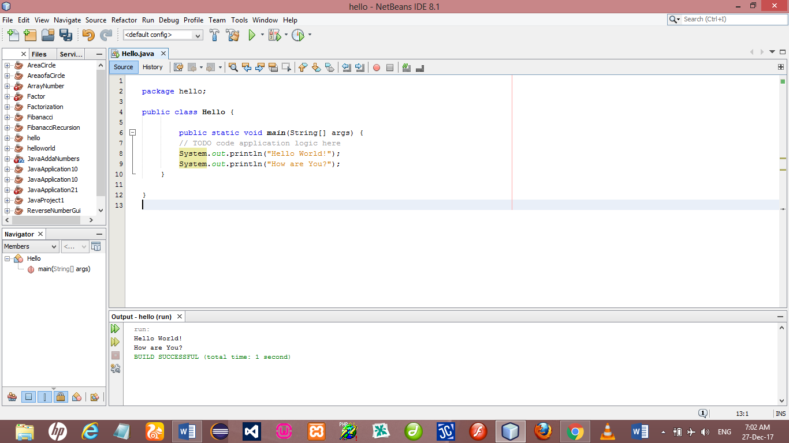

Q3. Add a comment to the program (anywhere), recompile, and run it again.

The new comment should not affect the result.

**Answer**:

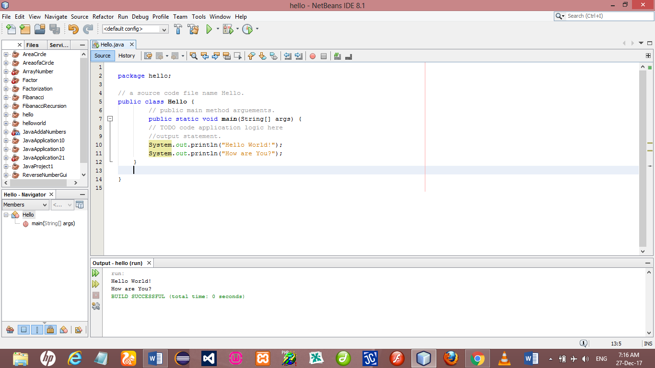

**Exercise 1.3**

Q. Starting with the hello world program, try out each of the following errors.

After you make each change, compile the program, read the error message (if there is one), and then fix the error.

1. Remove one of the open squiggly braces.

2. Remove one of the close squiggly braces.

3. Instead of main, write mian.

4. Remove the word static.

5. Remove the word public.

6. Remove the word System.

7. Replace println with Println.

8. Replace println with print.

9. Delete one of the parentheses. Add an extra one.

***Errors Detected***

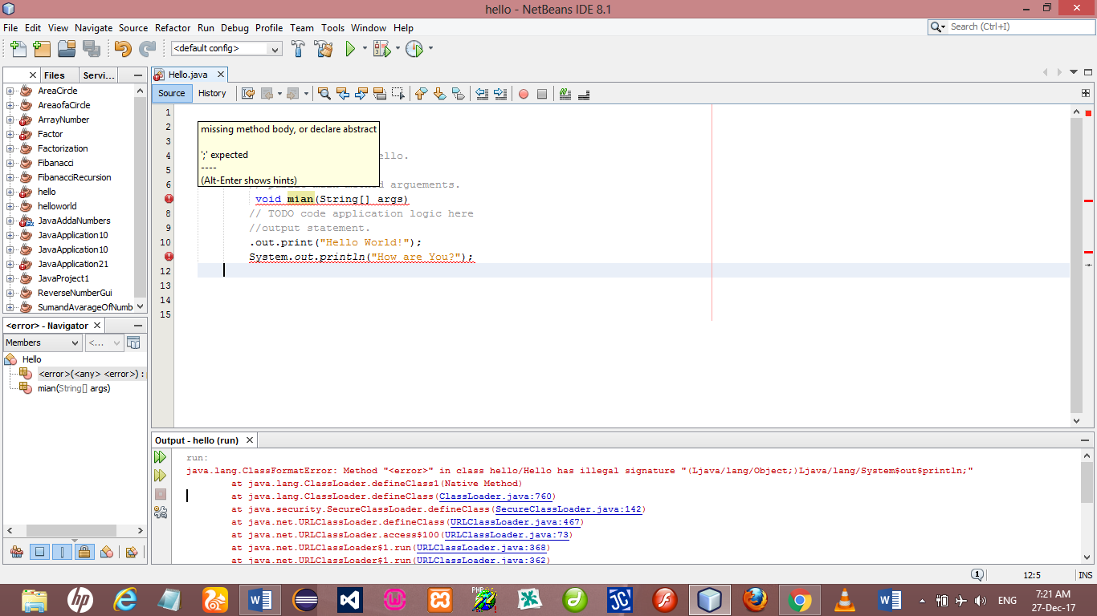

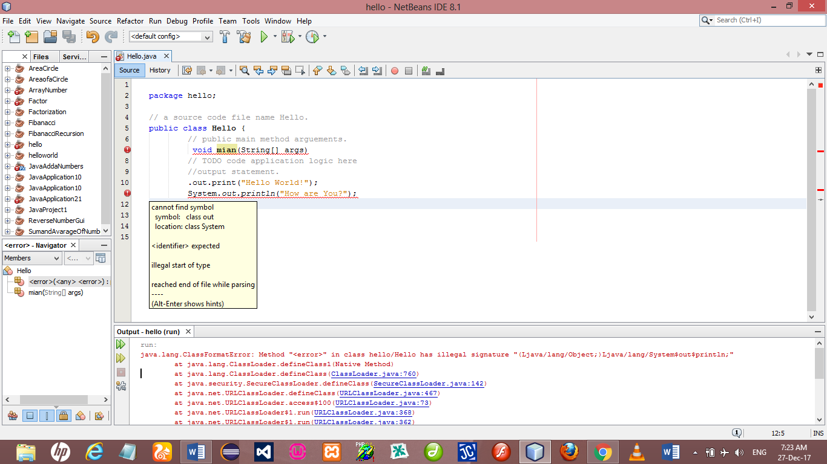

**Corrected Errors**

